- \Operation\Booklet transfer\Booklet vibration
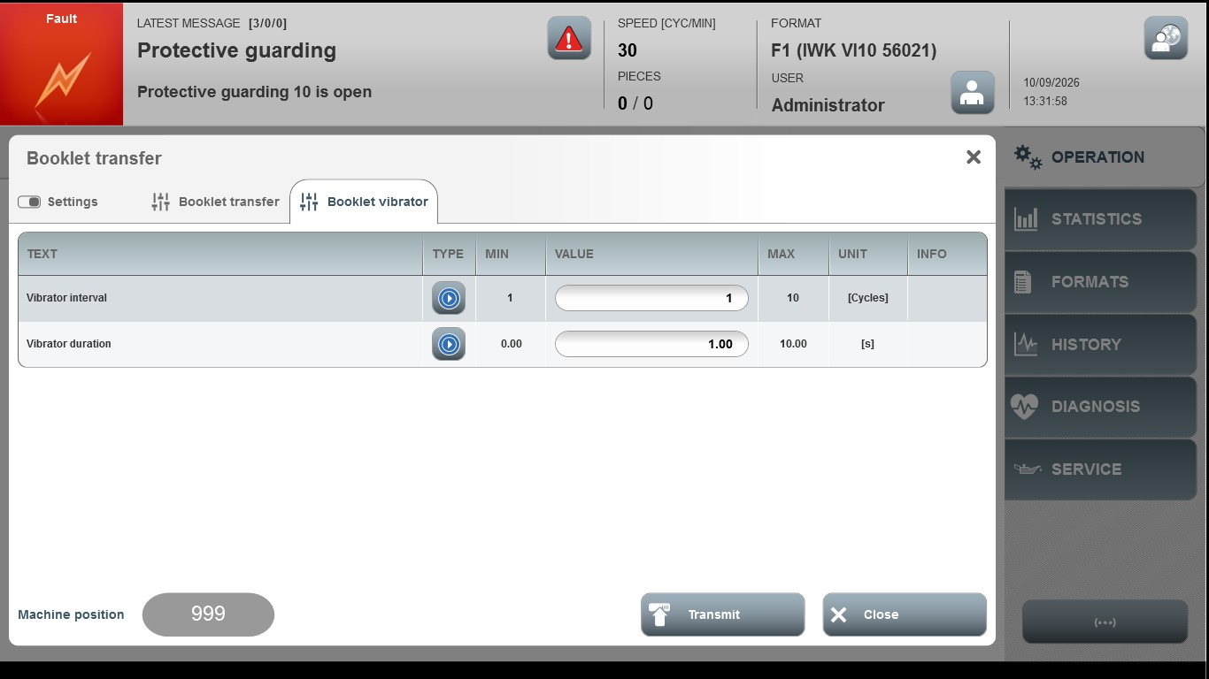
Acceptance criterion | Limits | Pass / Fail: Dev-No. | Date | Initials
Screen matches screenshot | N / A
Vibrator interval | 1 … 10
Vibrator duration | 1.00 … 5.00

